The Academic Progress Report (APR) displays the academic requirements you need to graduate, including those you have already completed and those you have not completed. This important document guides you through the steps you need to take in order to graduate on time.

Use this guide to view and read your Academic Progress Report (APR). Remember to always consult your academic advisor with any questions.

This reference will cover:

A. Overview / What is an Academic Progress Report?
Why Do I Have an APR?
How Does It Work?
Tips on How to Read Your APR
B. How to Find My Academic Progress Report
C. Reading My APR
See Progress Towards Graduation
See completed courses that contribute hours to graduation
See completed courses that do NOT contribute hours to graduation
See Progress Towards Completing my Program of Study
See academic requirements I have completed
See academic requirements I have NOT completed
See my courses that contribute to academic requirements
D. How to Find Courses That Will Satisfy an “Unsatisfied” Academic Requirement
E. How to Print the APR

Overview / What is an Academic Progress Report?

The Academic Progress Report (APR) is an automated tool that tracks your progress towards degree completion.

Why Do I Have an APR?

The Academic Progress Report (APR) helps you keep track of your degree requirements, monitor your GPA, and record what courses you’ve taken in order to graduate. Additionally, your advisor uses your APR to guide your course selection during registration and the registrar uses your APR to certify you for graduation.

How Does It Work?

Workday student accounts store academic work, including grades, hours and units, transfer units, completed courses, and current courses. Workday also stores academic requirements needed to graduate, including minimum GPA, undergraduate essential skills and general education courses, and the program of study requirements for each major, minor, graduate degree, emphasis, concentration, or certificate.

As students complete coursework, it is arranged alongside the corresponding academic requirements in a way that maximizes the fulfillment of these requirements. This optimized arrangement is the Academic Progress Report.

In other words, the Academic Progress Report shows you exactly which requirements are completed and which are still needed to keep you on track to graduate.

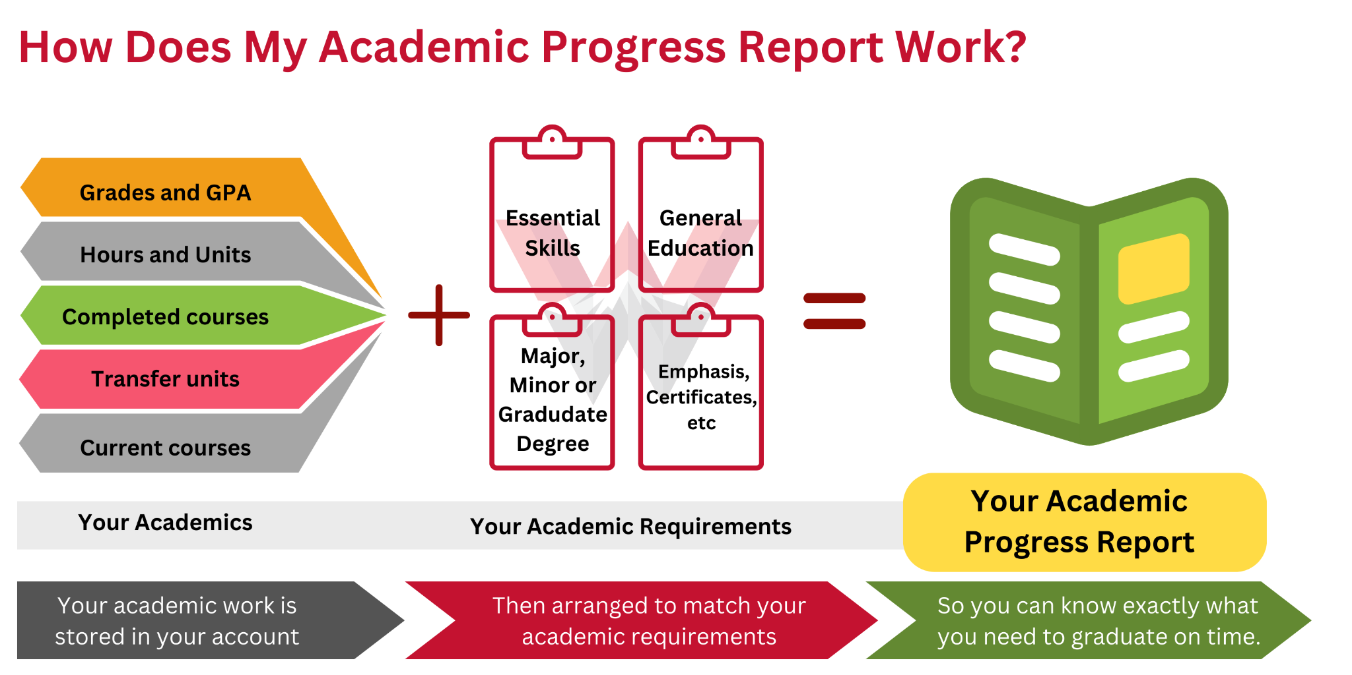

Tips on How to Read Your APR
The APR empowers you to make important decisions about which courses you need or do not need to take. Take the time to learn the APR’s 1) organization and 2) functionality (see below). Remember to reach out to your advisor with questions.

Organization
- Page Layout
Your progress towards overall graduation requirements is displayed at the top of the page (as well as the option to print your report). At the bottom, the APR displays progress towards your program(s) of study.
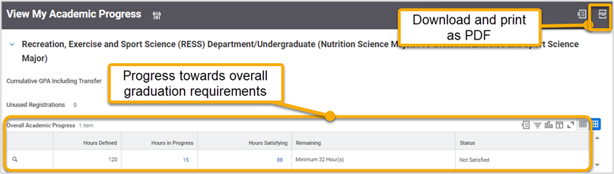
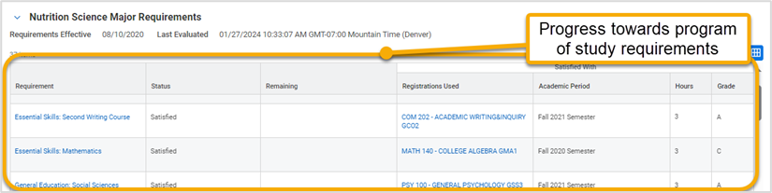
- Requirement Blocks
Each program of study has its own set of requirements. Consequently, each program of study will have its own requirement block. Each requirement block shows the requirements for Essential Skills, General Education, Graduation Requirements followed by that particular program of study.
The blocks default in expanded view. If you have more than one program of study (e.g. double major, or a major and a minor) you can collapse each block to narrow what you can and cannot see.
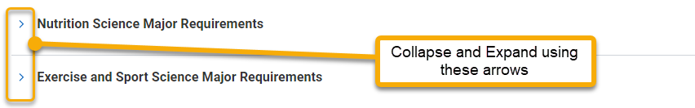
- Reading Requirement Blocks
Each column displays important information about the requirement (you will learn more about each column later in this guide). Each column can be sorted (arranged in ascending or descending order) or filtered (display only certain values) to narrow what you can and cannot see.
To ensure you see all requirements, select “View All” at the bottom of the block.
To view requirement details, such as minimum grade required or acceptable courses, hover over the requirement title and click the related actions button .
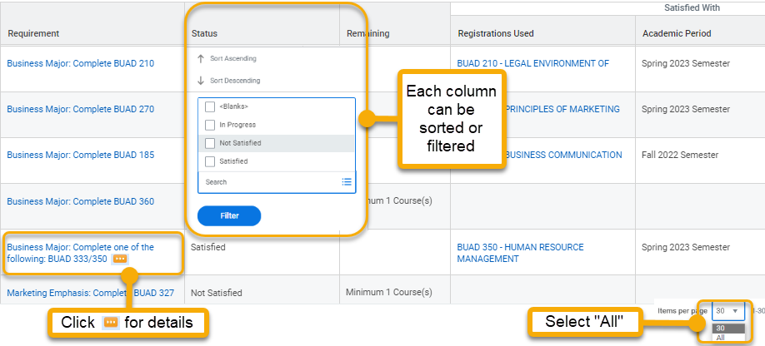

Functionality
- Fulfilling Requirements
As you complete courses, your account will automatically sort and assign your work to fulfill the maximum number of academic requirements. Although these assignments may change slightly as you complete additional classes, the “Satisfied” status is permanent and will not change. Confirm your course selection with your advisor to ensure they will fulfill your unsatisfied requirements.
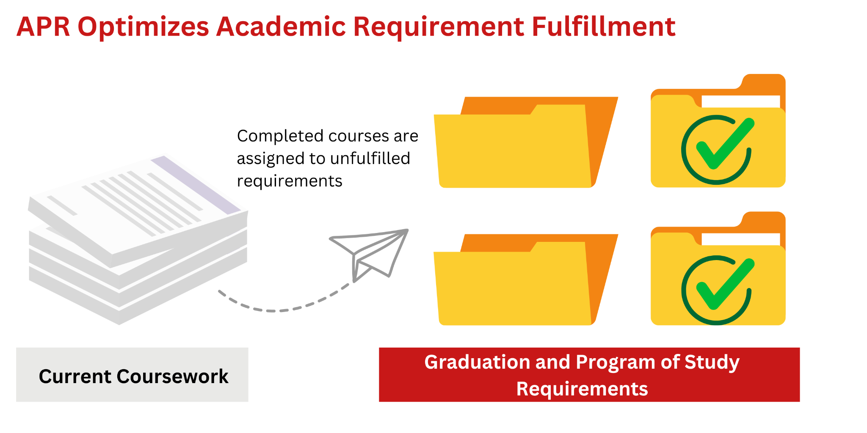
- Updating your record
Your APR is not updated in real time. Although some events will update your APR within 24 hours, such as adding or dropping a course, your APR will not routinely update daily. The day/time of the last update is in the Last Evaluated field. If you have a concern, connect with your advisor to manually update.
- Satisfying requirements
The APR uses only completed coursework to set a requirement to “Satisfied”. Courses that are not yet complete will render the status “In Progress”. You must complete the course with the minimum required grade in order to successfully earn hours towards the requirement. Once your minimum required grade is posted, your APR will update within 24 hours changing the requirement status to “Satisfied”.

How to Find My Academic Progress Report

- Log into Workday. From the Academics app, click “View My Academic Progress”.

- Click “OK”.
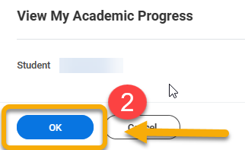
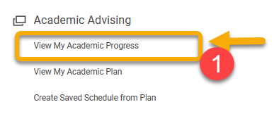

C. Reading My APR

Learn to read the two primary areas in your APR.

See Progress Towards Graduation

Your progress towards graduation is at the top of the View My Academic Progress page, in a table called Overall Academic Progress. This table is a summary of your academic progress towards graduation, not your program of study. It displays:

- Hours Defined - Total hours required to graduate
- Hours in Progress - Hours you’re currently taking
- Hours Satisfying - Your completed hours that contribute towards graduation
- Remaining - Your remaining hours needed to graduate, not including hours “In Progress”
- Status - Your graduation status

Example:

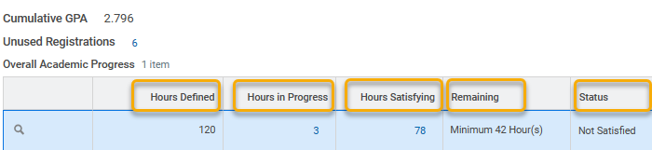

In the example above, 120 hours are required to graduate. This student has earned 78 hours and when he finishes this current academic period, he will earn 3 more. To graduate, he needs at least 42 additional hours.

Here are other ways you can use the Overall Academic Progress table.

If you want to… | …then
See the courses you’re currently taking and how they contribute to graduation | Hover over the little number in the Hours in Progress tab to reveal a small triangle. Click the triangle and click “View Details”.
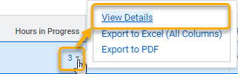

Here is the window that opens.

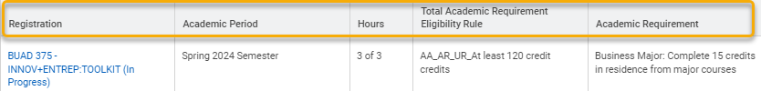

It displays the course(s), the current period, # of hours contributing towards graduation, and the graduation requirement of 120 hours.

In this example, the student is only taking one class. The class is contributing 3 hours to graduation AND to his program of study, as listed in the Academic Requirement column.

Other Academic Requirement labels include “Graduation Requirement”, ”General Education”, or “Essential Skills”.

If you want to… | …then
See completed courses that contribute hours to graduation | Hover over the little number in the Hours Satisfying tab to reveal a small triangle. Click the triangle and click “View Details”.
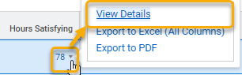

Here is the window that opens.

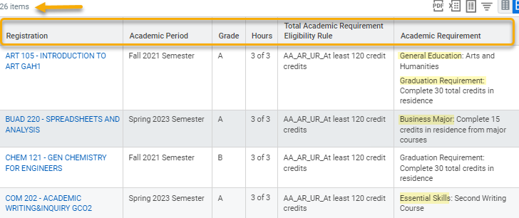

It displays the course(s), when you took the course, your grade, # of hours contributing towards graduation, and the graduation requirement of 120 hours.

In this example, the student has taken 26 courses contributing to graduation.

The Academic Requirement column tells us that in addition to contributing to 120 total hours required for graduation, the first course is fulfilling a general ed requirement and a graduation requirement. Also, the second course is fulfilling a program of study requirement and the fourth is fulfilling an essential skills requirement.

If you want to… | …then
See completed courses that do NOT contribute hours to graduation | Hover over the little number next to Unused Registrations to reveal a small triangle. Click the triangle and click “View Details”.
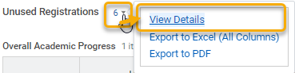

Here is the window that will open.

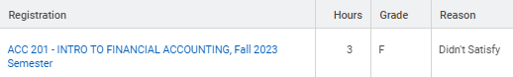

The window displays the course(s), when you took the course, # of hours, your final grade, and the reason the course doesn’t qualify.

In this case, the student did not earn the minimum grade required to qualify the hours towards graduation. Incomplete or withdrawn courses will also be included here.

TIP: You have the option to export and download these details as excel or PDFs. This may be helpful if you want to discuss this information without access to a computer or wifi.

See Progress Towards Completing my Program of Study

Near the bottom of the Academic Progress page, you will see a table of academic requirements called the Requirement table. This table displays a detailed outline of your progress towards completing academic requirements associated with your program of study. Requirements are shown separately for each program of study (primary major, secondary major, primary minor, secondary minor, ect).

TIP: Be sure you can see your complete academic progress report by clicking “All” at the bottom of the table.



The six columns in the Requirement table are Requirement, Status, Remaining, Registrations Used, Academic Period, Hours, and Grade.

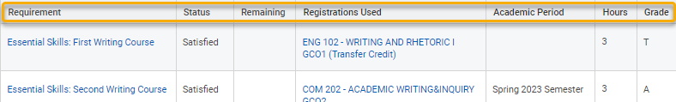

Below is an explanation for each column.

Column Name | Summary
- Requirement | Lists academic requirements for graduation and your program of study.
Details: Graduation requirements are listed first - Essential Skills, General Education, and Graduation Requirement. Your program of study requirements are listed second.
- Status | Displays your progress towards satisfying the academic requirement.
Details: Options include Satisfied, In Progress, or Not Satisfied.
- “Satisfied” = student completed the academic requirement
- “In Progress” = student completed some coursework that contributes to this requirement, but additional coursework is needed. OR the student is currently enrolled in a course that will contribute to this requirement when the final grade is issued
- “Not Satisfied” = student has no courses that contribute to the requirement.
- Remaining | Displays the remaining elements you need to meet the requirement
Details: If blank, then you do not need to contribute additional hours and the “Status” column will indicate “Satisfied”.
- Registrations Used | Displays the completed courses that contribute to the academic requirement.
Details: All your courses that contribute to a requirement are displayed here.
You may also see rows that have a course under the “Registration Used” column and no requirement in the Requirement column. Here is an example:
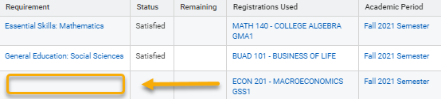

The table allows only one course in this column per row. Requirement cells will be blank if you complete multiple courses that contribute to one, single requirement. To accommodate, the table creates additional rows under the related academic requirement.

In this example, the student completed BUAD 101 and ECON 201. Both courses contribute to the General Education: Social Sciences academic requirement.

Note: Some requirements require multiple courses, and the requirement will not be satisfied until all required courses have been completed.
- Academic Period | This is the academic period associated with the corresponding course.
Details: This field is a helpful reminder of when you took each course.
- Hours | Displays the completed credit hours that are applied to the requirement.
Details: This field only applies to courses contributing hours. Credit hours are listed for courses completed and courses that are in progress.
- Grade | Displays the final grade you received
Details: You will see a “T” in this column for credits transferred to WCU from another institution. You will not see a grade for courses in progress. Only the final grade is posted here.

Following are ways you can use the Requirement table to prepare for registration:

If you want to… | …then
See academic requirements I have completed | Review the “Status” column in the table. The academic requirements labeled “Satisfied” are completed and do not need to register for additional hours. Congratulations!
Here is an example:

If you want to… | …then
See academic requirements I have NOT completed | Review the “Status” column in the table. The academic requirements labeled “Not Satisfied” and “In Progress” are not completed and require your attention.
Here is an example of a requirement with Status: “Not Satisfied”. To change the status to “Satisfied” the student must complete the course, ACC 202.

Here is an example of a requirement with Status: “In Progress”. The requirement specifies the student must complete 15 upper division credit hours from his program of study. This table displays five courses contributing to this requirement, but 3 of these courses are “in progress”. This means the student is currently enrolled in these 3 courses. Notice there is no final grade assigned.
When the courses are complete and the final grade is posted, the student will have earned the minimum 15 hours and academic requirement will become “Satisfied”.
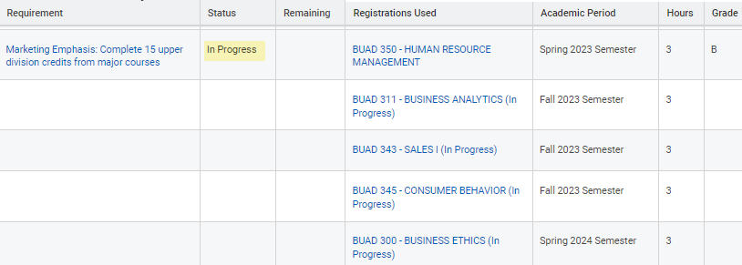

In this example, the status is “In Progress”. The student completed one course that contributed 3 hours. However, according to the table, the requirement demands the student complete 6 additional hours.
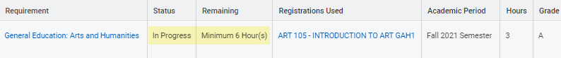

If you want to… | …then
See my courses that contribute to academic requirements | Review the “Registrations Used” column in the table. Courses that contribute to an academic requirement will be listed in this column alongside the academic period in which you took the course, hours earned, and your final grade.
In this example, the general education requirement is satisfied with the PHYS 200 course. The student does not need to take any more general education science courses.

In this example, the course, PHYS 200, is listed twice because it contributes to two different academic requirements.
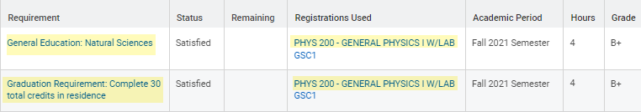

Remember to click “All” at the bottom of the table to see all your courses.


D. How to Find Courses That Will Satisfy an “Unsatisfied” Academic Requirement

All the information you need to compile a list of courses needed to graduate and complete your program of study is on the Requirement table. Be thorough and review the table carefully. Follow the steps below to get started and check out the examples to see how the process works:

To create a list of courses needed to meet graduation and program of study requirements:

Step 1) Identify academic requirements labeled “Not Satisfied” or “In Progress” in the Status column.

Step 2) Review the # of hours in the Remaining column. This tells you how many hours the student ultimately needs to complete.
Step 3) Click the related actions button in the “Requirement” column to view all course options that could contribute to the requirement.

Step 4) Create a list of these courses and select those the student wishes to register for during the next registration window.

Below are examples of these steps.

Example #1
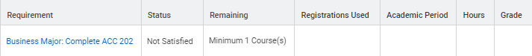

In this example, the requirement clearly says the student must “Complete ACC 202”. That means the student must complete this one, specific course. Additionally, under “Remaining”, the table says that one course remains. When the student completes ACC 202, this requirement will display “Satisfied”.

Before proceeding, review all requirement details. To view details, hover over the academic requirement to display the related actions button .

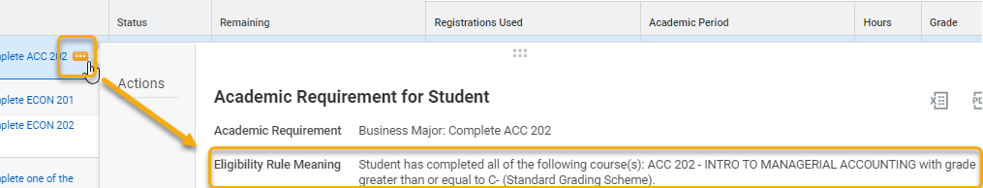

In this case, we now see the additional detail that a grade equal to or better than C - is required for this course to contribute to the Complete ACC 202 academic requirement.

Example #2
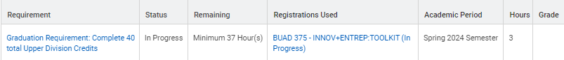

In this example, the requirement tells us that the student must complete 40 upper division courses. Under Status, we see “In Progress” because the student is currently taking one class that will contribute 3 credits to this requirement.

When preparing for registration, always glance at the Remaining column. While the requirement is “In Progress”, there are 37 remaining hours to complete. This requirement deserves attention.

While the requirement seems straightforward, always click the related actions button for details.

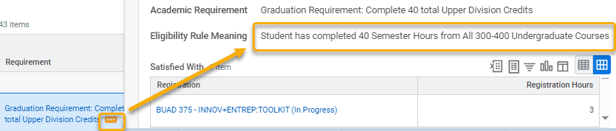

The details direct your course research towards 300-400 level courses. Only these courses will satisfy this academic requirement.

Example #3

In this example, the academic requirement shows “In Progress” in the Status column because the student has completed one contributing course.

When preparing for registration, always glance at the Remaining column. According to the Remaining column, the student needs to complete 6 additional hours. This requirement needs attention.

The requirement title, General Education: Arts and Humanities, does not specify the courses that contribute to this academic requirement. To learn which courses contribute to this requirement, click the related actions button.

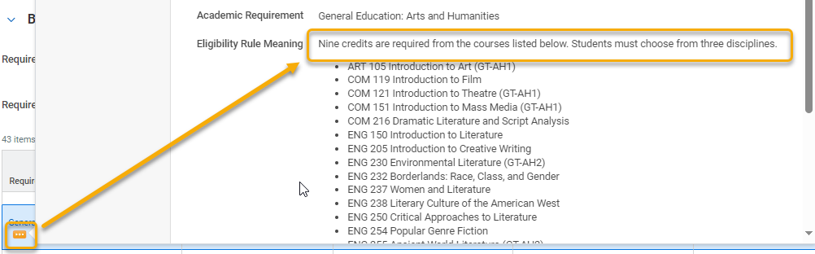

In this case, we now see that “nine credits are required from the courses listed below” AND “students must choose from three disciplines”. Additionally, a list of applicable courses are listed to support registration planning and course research. If you are preparing for registration, consider downloading or copying/pasting these courses into your list and using it as a reference.

E. How to Print the APR

- From the My Academic Progress page, locate and click the excel or PDF icon in the title bar. Download the report and print, if desired.



